YUMMY, YUMMY POPCORN
The 4Ps of Marketing

Product Specialist ____________________________________

Place Specialist ____________________________________

Promotion Specialist ____________________________________

Price Specialist ____________________________________

Directions: It will be best if you have 4 people in your team. You can do it with 3 but it will be a lot of work. Read through the project (all pages).

- One person will be the team leader for the PRODUCT part of this assignment.
- One person will be the team leader for the Place part of this assignment.
- One person will be the team leader for the Promotion part of this assignment.
- One person will be the team leader for the Price part of this assignment.

Each person will choose a job and become the “expert” in that section of the project. Write each expert’s name on the line for the job he/she has chosen. Each person will have an opportunity to be a team leader.

If you have only 3 people in your team, then choose one person to be a specialist over 2 areas.

Read carefully!
Do your best work!

Product

PRODUCT DEVELOPMENT

The president of our company (your teacher) has given us the task of coming up with a new snack food based on popcorn. New food product development involves the input of several members of a team bringing together a range of skills to test and develop recipes. Also, included are members of the marketing team to decide how the product will be priced and promoted, and how the product will be distributed to stores.

Essentially, the new food product must have overall appeal and be attractive, with a good flavor. For a snack food, it must be light, easy to eat, convenient, transportable, tasty and fun.

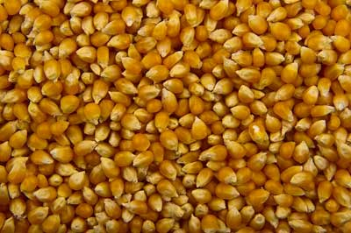
Popcorn is a whole grain maize product, grown extensively in the Midwest, where the majority of popcorn sold worldwide is grown. It resembles corn-on-the-cob (sweetcorn) in appearance and cultivation, although only popcorn kernels have the ability to pop. Popcorn can be ear-harvested, where the whole ear of corn is cut and stored for 8-12 months, until the moisture levels in the kernels reach optimum levels. At this point, the kernels are stripped from the cobs and graded to eliminate ones that are too small to pop efficiently.

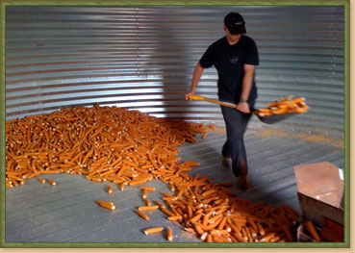
Popcorn can also be harvested by the combine method where the corn cobs are picked and shelled simultaneously. The kernels are then dried with hot forced air, packed, and distributed for sale.

Popcorn’s ability to pop lies in the fact that the kernel contains a small amount of water stored in a circle of soft starch inside the hard outer casing. When heated, the water expands, creating pressure inside the center until eventually the casing gives way and the kernels explode and pop, allowing the water to escape as steam, turning the kernels inside out.

Kernels that do not pop are known as “old maids.” They do not have sufficient water contained within the starch to create the buildup of pressure needed to pop the kernel.

PRODUCT OBJECTIVES

Understand the 4Ps of marketing: Product, Place, Promotion, and Price

PRODUCT ASSIGNMENT

You and your team will be creating a new flavor of popcorn. Your Target Market will be teenagers. That means your popcorn flavor(s), package design, and advertising will be designed for teenagers.

- Discuss with your team the various flavors of popcorn you may have tasted in your personal life.

- As a team develop ideas for flavoring popcorn. Brainstorm. Consider what you know about different salts, seasonings, herbs and spices, flavored butters to drizzle onto hot popcorn, sweet flavorings such as caramel or brown sugar, or “trail mixes” with dried fruit and nuts.

- Consider all the ideas discussed. Look at the ingredients provided by Ms. Revoir. Decide what flavor(s) your new popcorn will have. Write the flavor(s) here:

- Ms. Revoir will provide several flavorings as you have seen. If your team desires something else, you will need to bring it to class on “Popcorn” day.

Ms. Revoir will also provide approximately 1 bag of popcorn for each team.

On the day set aside for this assignment you will pop the popcorn, mix the ingredients and conduct a taste test. A taste test is where people sample your popcorn and critique it. This is done so you can make your product better before it is mass produced.

NUTRITION LABEL
Food labeling laws exist to protect the consumer and have been changed over the years as our understanding of food and nutrition grows. As consumers become more aware and knowledgeable of nutritional issues, consumers have asked for more labeling on packages. Armed with this knowledge, consumers can avoid certain ingredients if they wish, which is especially important if they are following a specific diet or have food allergies.

The following points summarize the functions of food labeling:

It must convey information to the consumer, giving details of the product that will enable them to make informed choices, thereby helping consumers to decide between brands and package sizes, consider health consequences, value for money, and so on.

Food labeling laws require the labeling on packaged food to fulfill a number of important functions. Where applicable, labeling should:

- Show the name of the food
- Show the amount of the food in the package
- List the ingredients used to make the food, in weight order
- List the nutritional content of the food and serving sizes
- State the name and address of the manufacturer, packer or distributor
- State the country of origin
- State how long the product can be stored and under what conditions
- Give information on how to prepare and cook the food
- Give a date mark to indicate when the product must be “used by” or is “best before” which is critical on items that are highly perishable and could easily cause a food safety risk
- Give a warning if the food is self-pressurized
- Give accurate statements regarding the healthy or nutritional nature of a product using specific FDA guidelines
- Give an accurate representation of the food contained in the package if photography is used

- Taking guidance from the bullet points above, write the exact information that will be in your nutrition label here. Ms. Revoir has started the list for you. (5 points)
- Popcorn
- Butter
- Salt
- ___________________________________
- ___________________________________
- ___________________________________

MARKET RESEARCH

Before a product is mass produced and sold to consumers, a small quantity is made and it is tested. People, like you and me, are asked to taste the product and give their opinion. The more honest the person is the more information you will have to improve your product and make it a success.

- Now that you have an idea of what your product will be and how it might taste based on the ingredients, make a list of questions that you would ask a “taste tester” after he/she has tasted the product. Write your questions here. Please have 5 to 10 questions ready by taste testing time! (5 points) Ms. Revoir has written a couple of questions for you. You must create at least 3 more questions.

- What do you like about the popcorn?
- What do you dislike about the popcorn?

- Let at least 3 people in our class to “sample” your product. Ask each person the questions above and write down their answers here:

- After the taste testing, go over the taste tester’s answers. Should you add/subtract something to make your popcorn better? Analyze the data. What conclusions can you draw from the taste tester’s comments? (This answer is worth 25 points!)

